* System Model

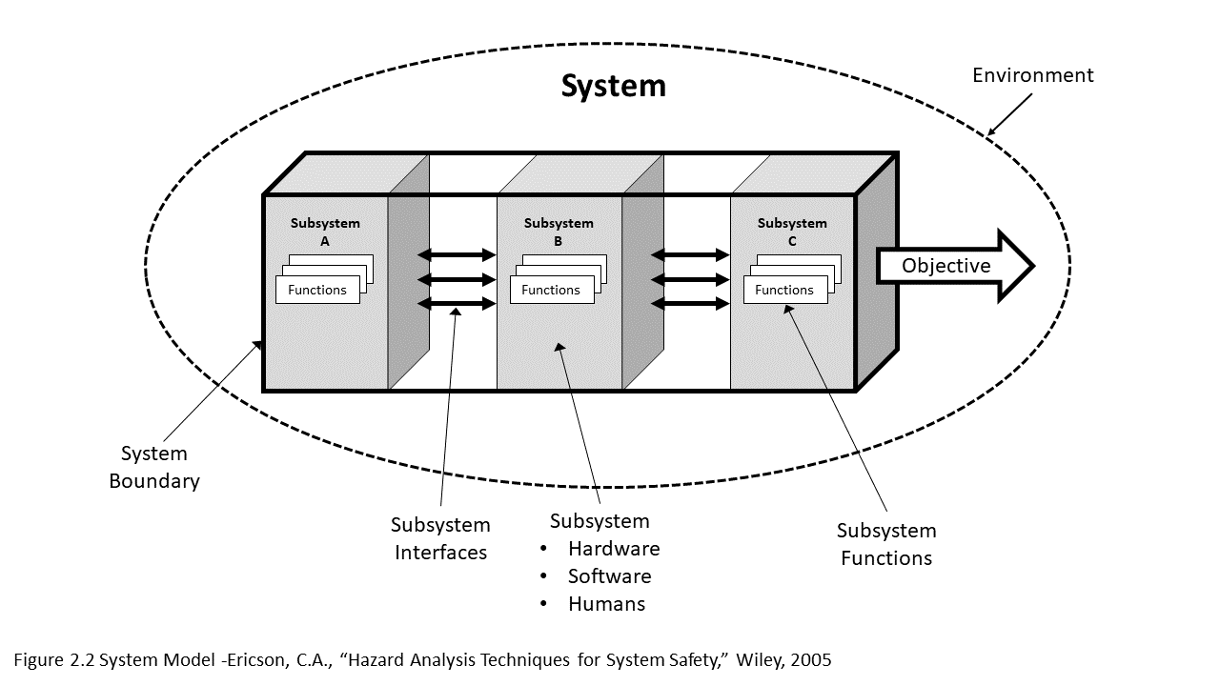

**Notification system tells suppression system how and when to work**

* A Fire Safety System

**Detection system active the notification, while certain notification can reduce false alarm**

**Environment:**

* **Potential Application like buildings or etc.**
* **Environments like human interference, ignitions material and so forth**

**Hardware:**

**Sprinklers, Fire Pump, Standpipe Hose Station**

**Software:**

**None**

**Human:**

**Trained people or dwellers**

**Hardware: Bells, Flash, or horn/strobes**

**Software: Simple logical system to determine where and when to notify.**

**Human: Fire department personnel, dwellers, etc**

**Subsystem Functions:**

* **Process the signals from the detection devices.**
* **Active notification devices like bells or emergence light**
* **Notify the fire department**

**Hardware: Detection devices, like heat detectors or pull station.**

**Software: None**

**Human: No human involvement is common here.**

**System Boundary:**

* **Wrapped materials keep systems from environment**

**Subsystem C**

**Suppression System**

**Subsystem B**

**Notification System**

**Prevent people and properties from fire.**

**Objective**

**Subsystem Functions:**

* **Suppress or control the fire**
* **Maintain a relative safe environment**

**Subsystem Functions:**

* **To detect the signal or appearance of fire from heat, light, noise or videos.**
* **Sent the signals to the notification system by wire or other measures.**

**Subsystem A**

**Detection System**

**A Fire Safety System**